HealthApp Automation-Doctor Module

Pre-requisite:

As soon as you import project in eclipse, update the project using maven update option as below. This is to resolve issue if any maven dependency not downloaded properly:

1. Right click on project : Go to “Maven” : Select “Update Project”

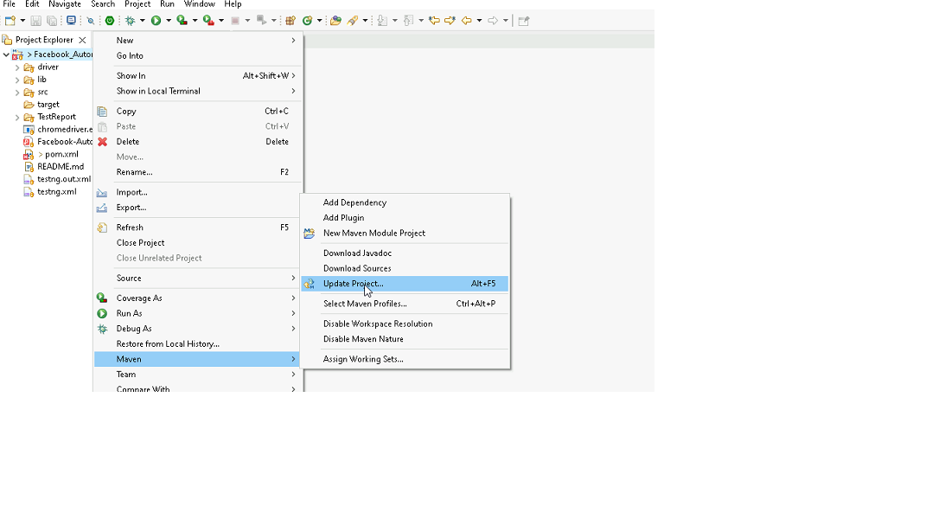

1. In Update Maven Project Box Select “Force Update of Snapshots/Releases” and click OK

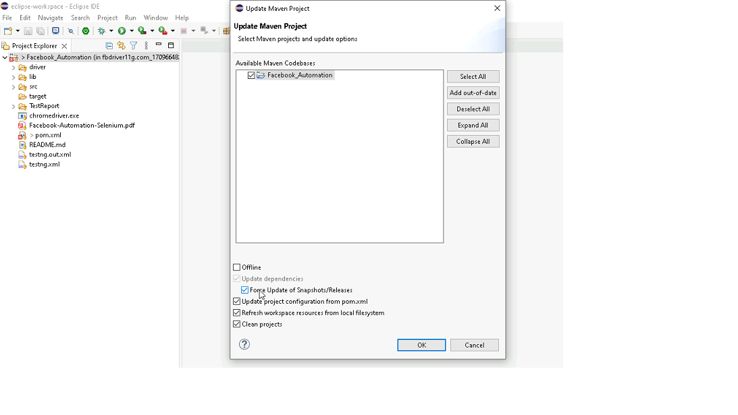

Template Code Structure:

1. Below are the packages and files you will be required to work upon.
2. Other Files and packages you can ignore.
3. In other Files and packages do not do any changes. It would affect your evaluation.
4. You are not required to work in “Test” Folder. Files there are non-editable. Editing those files and trying to save them will throw error and would affect your evaluation.

|  |  |  |
| --- | --- | --- |
| **Package** | **Class/File** | **Description** |
| src/main/java/coreUtilities/utils/ | FileOperations.java | 1. Contains methods to read from excel file. 2. Method is in templated form. 3. **You will be required to implement these methods as very first activity, because even URL to navigate to, is read using these methods.** |
| /src/main/java/pages | doctor_Pages.java | 1. All core activities (mentioned in list above) to be performed here. 2. The comments associated with each templated method here describe the expectation. 3. You can define locators and xpath here. 4. Declare any variable/object you need to share data/status between different methods. 5. Do not modify the signature of methods declared here. 6. You can create additional supportive common methods in CommonEvents class. |
| /src/main/resources/ | Config.xlsx | URL to navigate to. Already URL is defined here |
|  | expected_data.xlsx | Contains data to fill in form |
| /src/main/java/coreUtilities/utils | CommonEvents.java | 1. Contains all common activities. 2. Certain templated common method declared here. 3. You implement them as per your need. 4. You can add any additional method for common activity here |
|  | Testng.xml | Execution needs to kick started from TestNG xml |

PROBLEM STATEMENT

Need to automate the following activities using Selenium + Java.

Key Activities to implement:

|  |  |  |  |  |
| --- | --- | --- | --- | --- |
| **Sl No.** | **Summary** | **Action** | **Expected Result** | **Validation Rules** |
| **1** | * Navigate to the URL. * Retrieve Title and URL of the current page. * Verify Title & URL: Check if the title & URL matches the expected title. | 1. Go to url : **https://healthapp.yaksha.com/**  2. login as valid credential (username : **admin** , password : **pass123**) and click on "SignIn" Button  3. get the title and url of the current page 4. validate the title and url of the current page | Title should be : DanpheHealth Url should be : https://healthapp.yaksha.com/ | **Title** : Validate the title of the web page  **URL** : Validate the URL of the web page |
| **2** | Verify that Doctor module is present or not ? If Present, then expand the Doctor module and verify all presence of sub mudules under the Doctor module. | 1. User must be login the health app 2. verify that, Doctor Module is present or not in left navigation 3. if Doctor Module is present, then Click on the expand icon of the Doctor Module  4. then verify the follwing sub module under the Doctor Module Sub modules are :  **Out patient ,  In patient department ,  Patient Record** | Doctor Module should be present in left navigation All sub-modules should be displayed correctly. Expected Sub modules are :  **Out patient ,  In patient department ,  Patient Record** | **Link** : Validate existency (Presence/Visibility) and operation (Click) |
| **3** | On the **Doctor** Module's "Out Patient" Sub module, select the **"Show Doctor Wise Patient List"** check box and verify that is **"Show Doctor Wise Patient List"** check box is selected or not? After validation, uncheck the **"Show Doctor Wise Patient List"** check box. | 1. User must be present on "Out Patient" Sub module of "**Doctor"** Module. 2. verify the **"Show Doctor Wise Patient List"** check box is present or not ? 3. If Present, then click on the  **"Show Doctor Wise Patient List"** check box 4.Verify the "Show Doctor Wise Patient List" check box is selected or not  5. After validation, then uncheck the **"Show Doctor Wise Patient List"** checkbox | Show Doctor Wise Patient List' checkbox should be check & uncheck | **Checkbox** : Validate existency (Presence/Visibility) and operation (Check, Uncheck) |
| **4** | On the Doctor Module's "**In Patient Department"** Sub-Module, verify that "Department filter" dropdown is Present.  If present, then select the "NEUROSURGERY" from the "Department filter" dropdown and validate "NEUROSURGERY" is selected or not? | 1. User must be present on "Out Patient" Sub module of "Doctor" Module 2. then click on the "**In Patient Department"** Sub-Module 3. Verify that the "Department filter" dropdown is Present. 4. If present, select the "NEUROSURGERY" from the "Department filter" dropdown  5. validate that "NEUROSURGERY" is selected or not | "Department filter" dropdown should be present. "NEUROSURGERY" should be selected from "Department filter" dropdown | **Dropdown** : Validate existency (Presence/Visibility) and operation (Select Option) |
| **5** | On the **Doctor** Module's **"In Patient Department"** Sub-Module, verify that "**My Favorites"** and **"Pending List"** buttons are present inside the  "In Patient Department" Page | 1. User must be present on **"In Patient Department"** Sub-Module of "Doctor" Module 1. then Verify **"My Favorites"** and **"Pending List"**  buttons are present or not in "In Patient Department" Sub-Module | "My Favorites" and "Pending List" buttons should be present. | **Button :** Validate existency (Presence/Visibility) and operation (Click) |
| **6** | On the Doctor Module's "In Patient Department" Sub-Module, clicking on "Pending List" buttons and it opens pending table record. Then click on "Show Details" from the first table record and it open the "Free Text Template" form. Then validate the title name of the "Free Text Template" form | 1. User must be present on **"In Patient Department"** Sub-Module of "Doctor" Module 2. click on "Pending List" buttons and it open the pending record table  3. then click on "Show Details" from the first table record and it open the "Free Text Template" form 4. then validate the title name of the "Free Text Template" form 5. then close the "Free Text Template" form 6. click on "Pending List" buttons , then it close the pending record table | title name of the "Free Text Template" form should be  **Free Text Template** | **Text :** Validate existency (Presence/Visibility) and operation (Read Text) |
| **7** | On the Doctor Module's "In Patient Department" Sub-Module, a table record pre display which is filter by department as "NEUROSURGERY". Then get the "Doctor Name" where the "Hospital Number" is "2312000010". Then Validate the Doctor Name is **Dr. Amit Shah** | On the Doctor Module's "In Patient Department" Sub-Module, Patient record table must be display which is filter by departmwnt as as "NEUROSURGERY". 2. then retrive the"Doctor Name" where the "Hospital Number" is "2312000010" from the table  3. then validate the Doctor Name | Doctor Name should be **Dr. Amit Shah** | **Table** : Validate existency (Presence/Visibility) and operation (Read Data) |
| **8** | On the "Surgical History" Menu Tab of Problem module of the Profile "Sonia Gandhi", clicking on the **"+Add New"** button from Surgical History List and it will open a "**Add Surgical History"** form. Then click on "Add" button of "Add Surgical History" form directly without filling any information, it will throw an error message in "**Search Problem*"** field.  Then Validate that Error Message : **Select ICD-11 Code** | 1. user must be on "In Patient Department" Sub-Module and Patient record table must be display which is filter by departmwnt as "NEUROSURGERY". 2. click on the preview icon from the table where "Hospital Number" is "2312000010" and it will navigate to the IPD page of patient "Sonia Gandhi" 3. then click on the problem module from left navigation 4. "Active Problem" Tab must be pre selected 5. then click on "Surgical History"  6. then click on "+Add New" button from Surgical History List and it will open a "Add Surgical History" form. 7. Then click on "Add" button of "Add Surgical History" form directly without filling any information and it will throw an error message in "Search Problem*" field.  8. Then Validate that Error Message : **Select ICD-11 Code** | Error Message should be "Primary Phone is required" | **Exception Handling and Error Logging** : Verify handling and logging of unexpected behavior in applications |
| **9** | On the Profile "Sonia Gandhi", Scroll to the "**Discharge Summary"** Module which is present in the left navigation. Click on "Discharge Summary" and it will navigate to the "DischargeSummary" page. Then scroll to the buttom of the page and verify that the "Save" button is present or not. | 1. user must be present on the "Sonia Gandhi" IPD Profile. 2. Scroll to the "Discharge Summary" Module which is present in the left navigation. 3. Click on "Discharge Summary" and it will navigate to the "DischargeSummary" page. 4. Then scroll to the buttom 5. then verify that the "Save" button which is present on the buttom of the **"Discharge Summary"** | User should successfully scroll to the buttom of the "Discharge Summary" page  "Save" button should be present on the buttom of the "Discharge Summary" page | Scroll : Validate the scroll on a page |
| **10** | On the buttom of the "Discharge Summary" page of Profile "Sonia Gandhi", verify that the "**Hospital Course"** text area is present or not? If Present, then highlight the "**Hospital Course"** text area as color yellow | 1. user must be present on buttom of the "Discharge Summary" page of Profile "Sonia Gandhi" 2. verify that the "Hospital Course" text area is present or not? 3. If Present, then highlight the "Hospital Course" text area as color yellow | "Hospital Course" text area should be highlight as yellow color | **Highlight :** Validate existency (Presence/Visibility) and operation (element should be higlight) |
| **11** | On the "Discharge Summary" page of Profile "Sonia Gandhi", verify that, **"Treatment During Hospital Stay"** textarea is present or not? If Present, then get the placeholdername of **"Treatment During Hospital Stay"** textarea and Validate that placeholdername. | 1. user must be present on buttom of the "Discharge Summary" page of Profile "Sonia Gandhi" 2. scroll to the top of "Discharge Summary" page 3. verify that, "Treatment During Hospital Stay" textarea is present or not? 4. then get the placeholdername of "Treatment During Hospital Stay" textarea 5. Validate that placeholdername | "Treatment During Hospital Stay" textarea should be present  place holder name of "Treatment During Hospital Stay" textarea should be **Treatment during hospital stay** | **Placeholder** : Validate existency (Presence/Visibility) and validate the placeholder name |
| **12** | On the "Discharge Summary" page of Profile "Sonia Gandhi", verify that, **"Condition On Discharge"** textarea is present or not? If present, then send the value to the "Condition On Discharge" textarea.  Then validate the entered value. | 1. user must be present on top of "Discharge Summary" page of Profile "Sonia Gandhi" 2. verify that the "Condition On Discharge" textarea is present or not? 3. if present, then send the value (read & write data from EXCEL) to "Condition On Discharge" textarea. 4. then validate the entered value of "Condition On Discharge" textarea | "Condition On Discharge" textarea should be present  The entered data should be correctly displayed in "Condition On Discharge" textarea | **Textbox** : Validate existency (Presence/Visibility) and operation (Click, Enter Text) **Attributes** : Validate existency (Presence/Visibility) and operation (get the text from the field) **Test Data Reading/Writing** : Validate the ability to read from and write to various data sources (Excel, DB, JSON). |
| **13** | On the "Discharge Summary" page of Profile "Sonia Gandhi", select "Yes" radio button from the "Show Result on Report" label and then verify that the "Yes" radio button is selected or not. After valodation, then deselect the "Yes" radio button from the "Show Result on Report" label | 1. user must be present on top of "Discharge Summary" page of Profile "Sonia Gandhi" 2. select "Yes" radio button from the "Show Result on Report" lebel, in that time "**Click the Components to show the results on report"** popup will comes and then close the popup 3. verify that the "Yes" radio button is selected or not. 4. After validation, then deselect the "Yes" radio button from the "Show Result on Report" label | "Yes" radio button should be selected, "Show Result on Report" lebel | **Radio Button** : Validate existency (Presence/Visibility) and operation (Select, Deselect) |
| **14** | On the "Discharge Summary" page of Profile "Sonia Gandhi", verify that the "**Pending Reports"** text area is present or not? If Present, then click & send value to the **"Pending Reports"** text area using the JavaScript | 1. user must be present on top of "Discharge Summary" page of Profile "Sonia Gandhi" 2. verify that the "Pending Reports" text area is present or not? 3. then click & send value to the "Pending Reports" text area using the JavaScript | User should able to click & send the value to the **"Pending Reports"** text area by using javaScript | **JavaScript Execution** : Validate the execution of JavaScript |
| **15** | On the "Discharge Summary" page of Profile "Sonia Gandhi", verify that the "Save" button is present or not? If present, then click on the save button directly without fill any information and it will throw a notification popup error message. Then validate that notification popup error message  **Failed Enter Manditory fields** | 1. user must be present on top of "Discharge Summary" page of Profile "Sonia Gandhi" 2. click on the save button directly without fill any information and it will throw a notification popup error message. 3. Then validate that notification popup error message  Failed Enter Manditory fields | notification popup error message should be  **Failed Enter Manditory fields** | **Popup Notifications** : Validate existency (Presence/Visibility) and operation (Read Data) |

NOTE: "Please do not delete any file in the src folder.  But you are free to add any other file".

Expectations:

1. Learners should write automation script using Java and selenium to automate all the steps in the above question. In other words, automation script should perform all mentioned steps.
2. Learners should not use any tools to create the xpath. They should develop the xpath/cssselector on their own.

IMPLEMENTATION/FUNCTIONAL REQUIREMENT

* 1. **CODE QUALITY/OPTIMIZATIONS**
     1. Associates should have written clean code that is readable.
     2. Associates need to follow SOLID programming principles.

EXECUTION STEPS TO FOLLOW

1. **You are mandatory required to run test cases for applications before final submission. Without which project evaluation will not happen.**
2. **You can launch test cases any time as follows: Right click on testng.xml and run TestNGSuite.**

|  |
| --- |
|  |

1. **Before final submission, you are also required to push your code to GIT. Following are the steps to follow:**

|  |
| --- |
|  |

In your project folder, you will find a batch file named git_commands

|  |
| --- |
|  |

Double-click the batch file to run it. It will run the commands to push your code to GIT.

|  |
| --- |
|  |

===============================================================================

All the Best